DEPARTMENT OF ELECTRICAL ENGINEERING & ELECTRONICS

Project Plan for project ‘Passive dynamic slope-walking bipedal robot’
Author: Jadyn Ross (201640204)
Project Supervisor: Heba Lakany
Project Assessor: Barry Smith

Declaration of academic integrity

By submitting this work, I confirm that I have read and understood the University’s Academic Integrity Policy.
By submitting this work, I confirm that I have acted honestly, ethically and professionally in conduct leading to assessment for the programme of study.
By submitting this work, I confirm that the work I am submitting is my own. I have not commissioned production of the work from a third party or used artificial intelligence software in an unacceptable manner to generate the work*. I have not copied material from another person or source, nor committed plagiarism, nor fabricated, falsified or embellished data when completing the attached piece of work. I have not colluded with any other student in the preparation and/ or production of this work.
*Software applications include but are not limited to, ChatGPT, Bing Chat, DALL.E, Bard

Table of contents

Project scope 3
Project objectives 3
Project Requirements 4
Work packages 6
Skills and Resource Audit 8
Appendix 1. A Gantt chart (1 Page) 10
Appendix 2. The risk assessment form. 11
Appendix 3. FYP ethics self-assessment. 16
References 16

Project scope

This project aims to design, model, and experimentally validate a passive dynamic bipedal walking robot capable of stable motion down an inclined plane using only gravitational and inertial forces. The robot will not rely on sensors, motors, or feedback control — instead, its walking gait will emerge from its geometry, mass distribution, and passive joint dynamics. The study will focus on achieving sustained walking on a slope of at least 5°, taking a minimum of five consecutive steps without external intervention.

The work builds upon the foundational research of T. McGeer [1], who demonstrated that efficient, human-like walking can arise from purely mechanical systems. Later refinements by M. Garcia et al. [2] and S. Collins et al. [3] further explored the stability and energy efficiency of such systems.

In contrast to modern actively controlled bipeds, such as Boston Dynamics’ Atlas [4], this project investigates a low-energy, low-complexity alternative that exploits gravity and mechanical resonance to generate natural gait cycles. Humans themselves utilize a natural gait cycle when walking down a slope to decrease energy usage. Due to this I will design the robot with human like proportions, a clear example of biomimicry. Through mathematical modelling, numerical simulation, and physical testing, the project will examine the relationship between mechanical design parameters, limit-cycle stability, and energy exchange during walking.

The results of this project will create a simple and low-cost setup that can be used to study how walking robots stay balanced and how their movement changes under different conditions. This work will help support future learning and research in energy-efficient, naturally moving robots, but also the analysis of natural human gait cycles – potentially assisting the understanding of human biomechanics. It will be useful for students, researchers, and designers who are interested in building robots that walk efficiently without relying on complex control systems and electronics.

Project objectives

Objective | S.M.A.R.T. reasoning
- Develop a mathematical model of the biped as a double inverted pendulum system using Lagrangian dynamics. | Clearly defines system behaviour through full equations of motion and impact maps; achievable with standard modelling methods and to be completed by Week 8.
- Convert the nonlinear dynamics into a state-space form suitable for numerical simulation and stability analysis. | Produces validated continuous and discrete state equations linking theory to simulation; achievable in MATLAB/Python by Week 9.
- Perform preliminary analytical stability analysis using linearisation and energy balance methods to identify feasible walking regions. | Evaluates limit-cycle stability via eigenvalue and energy checks; achievable with small-angle assumptions by Week 10.
- Develop a numerical simulation that reproduces at least five stable steps at a slope of ≥5° and determine the maximum slope angle before instability occurs. | Measures walking stability quantitatively through simulated steps and slope threshold; achievable using validated model equations by Week 13.
- Design and build a physical passive dynamic walker prototype that matches model parameters and demonstrates walking on a 5° ramp. | Demonstrates theory experimentally through ≥5 consecutive stable steps; achievable using laser-cut or 3D-printed parts by Week 18.
- Conduct experimental testing and compare physical gait behaviour with simulation results using step period, speed, and stability metrics. | Quantifies agreement between real and simulated motion within 15% deviation; achievable through motion capture or video timing by Week 20.
- Produce a final report and presentation summarising theory, simulation, and experimental findings, evaluating the robot’s performance and stability trends. | Completes academic assessment with full documentation of outcomes; achievable by Week 24.

Project Requirements

Category: Modelling
Identifier | Description
MOD-01 | A mathematical model will be developed using Lagrangian mechanic formulas, to represent the bipedal system.
MOD-02 | The nonlinear dynamics shall be expressed in ‘state-space form’, including heel-strike impact equations.
MOD-03 | The model will be designed for a slope of 0-10°.

Category: Mechanical Design
Identifier | Description
MECH-01 | The robot will consist of two identical rigid legs modelled as two double inverted pendulums, with a single hip joint and counter-swing arms. To be modelled on Fusion360.
MECH-02 | Each leg will have a length between 0.2m and 0.3m, consistent with the mathematical model and stability predictions.
MECH-03 | The total mass of the robot will not exceed 3kg, with the centre of gravity located symmetrically along the sagittal plane of the human body.
MECH-04 | The hip joint will provide low-friction passive rotation with an angular range of ±45°.
MECH-05 | All structural joint components will be manufactured using 3D printing and main limb and torso will be laser cut acrylic or wood

Category: Simulation
Identifier | Description
SIM-01 | Live simulation using ROS2 gazebo with a URDF file of the CAD design from Fusion360.
SIM-02 | The simulation will run an event-detection algorithm to identify heel-strike conditions and reset variables based on impact dynamics.
SIM-03 | The simulation environment must be adjustable for key parameters such as slope angle, mass ratio and leg length for sensitivity testing.

Category: Dynamic Performance
Identifier | Description
DYN-01 | The robot will walk passively down an incline of at least 5°, powered only by gravity.
DYN-02 | The robot should achieve a minimum of five consecutive stable steps without external actuation or human input.
DYN-03 | The robot shall maintain lateral balance within ±10 mm deviation from the slope centreline during motion.
DYN-04 | The robot’s step period shall remain within ±15 % of the predicted value from simulation.

Category: Analysis
Identifier | Description
ANA-01 | Step time, stride length, and overall stability will be compared against simulation results to confirm similar performance within a 15% tolerance.
ANA-02 | Utilize finite element analysis on fusion360 to verify joint strength under various conditions.
ANA-03 | Stability analysis using poincaré + eigenvalues. A bifurcation graph will show the behaviour as the system changes during parameter adjustment.

Category: Non-functional requirements
Identifier | Description
NFR-01 | Each simulation in MATLAB and ROS2 should run to completion without exceeding 10 minutes per iteration on a university mini pc.
NFR-02 | The robot shall demonstrate consistent behaviour over at least three repeat test runs without major mechanical failure.
NFR-03 | The physical prototype will be simple to assemble and operate safely by one person.
NFR-04 | All materials will be non-toxic and free from sharp edges after fabrication.
NFR-05 | The physical prototype will be simple to assemble and operate safely by one person.
NFR-06 | The simulation environment will be reproducible using documented MATLAB and ROS2 files.

Work packages
WORK PACKAGE DESCRIPTION
WP Title: | Literature review | WP number | #1
Start Event: | 22nd September 2025
Duration: | Throughout whole project timeline
Objectives:
To gain a better understanding of passive dynamic robot systems including gait cycle analysis, double inverted pendulum modelling and testing these through bifurcation graphs and Poincare maps. I will also research on simulation in a software built for dynamic robots (ROS2 gazebo etc.).
Task Description:
Read and review articles/reports/research papers on passive dynamic robot systems.
Document and analyse relevant research.
Inputs:
This work package requires almost no inputs apart from a laptop and some stationary.
Interfaces/links with other tasks or WPs:
This work package is intrinsically linked to all other work packages as it sets a foundation of the knowledge required to complete each section.
Deliverables:
Deliverables include the framework for gait cycle analysis, control systems model and equations, stability/non-linear dynamics analysis and functional simulation knowledge.

WORK PACKAGE DESCRIPTION
WP Title: | Model/system design | WP number | #2
Start Event: | 6th October 2025
Duration: | 4 weeks 8 weeks
Objectives:
Develop a mathematical model of the bipedal walking system based on passive dynamic principles. Represent each leg as a double inverted pendulum and define the corresponding equations of motion. Establish a simplified model suitable for numerical simulation and stability analysis (bifurcation and Poincare methods). Identify critical parameters that influence stability and step length on a slope angle of 5 degrees for example.
Task Description:
Formulate and utilize Lagrangian dynamic equations to model a double inverted pendulum. After this I will model the robot body, two legs and knees. With this I can calculate the inertial force required from the arms swinging as counterbalance. Apply impact conditions to simulate heel strike.
Inputs:
Information gained from work package 1 will be necessary. Gait analysis research, system assumptions and values for the desired performance criteria.
Interfaces/links with other tasks or WPs:
This work package has a direct impact on the feasibility of my design continuing forward, making this the most vital package. The model designed will be replicated on software and features on CAD.
Deliverables:
A complete mathematical model of a passive dynamic biped, using Lagrangian formulation. Translated non-linear equations of motion into a state-space format, that can represent the robot’s dynamic behaviour nicely. Key parameters such as size, weight, length of limbs etc will be decided based off this research. A small preliminary stability assessment using simplified assumptions. This step will confirm a feasible walking system before simulation testing.

WORK PACKAGE DESCRIPTION
WP Title: | CAD design | WP number | #3
Start Event: | 3 November 2025. 25th November 2025
Duration: | 4 weeks 4 weeks + 1 week off Christmas 22nd-29th
Objectives:
Translate the validated model/system design into a detailed 3D CAD design utilizing fusion360 software. Develop it to be lightweight, cost efficient, rigid and geometrically accurate. Design for an easy assembly and parameter adjustment. Have complete .stl files and to convert to URDF.

Task Description:
Sketch initial concept using the key parameters and correct geometry as set in the model/system work package. Develop parts for each lower leg, thigh and foot, then the body and arms. Include leg links, hip joint and semi-circular feet base.

Inputs:
Model parameters from system design (leg length, mass ratios, joint offsets), Material properties and fabrication constraints, and design requirements for slope walking at ≥5°

Interfaces/links with other tasks or WPs:
WP1 Literature review covers necessary background for CAD design
WP2 provides key dimensions and theoretical relationships
Deliverables:
3D CAD assembly of the complete robot, detailed part drawings with tolerances, material list and estimated total mass and exported manufacturing files (.STL, .DXF, .STEP) with URDF definations.

WORK PACKAGE DESCRIPTION
WP Title: | Simulation | WP number | #4
Start Event: | 3th December 2025. 29th December 2025
Duration: | 4 weeks 3 weeks
Objectives:
To simulate the robot’s passive walking dynamics, verify system stability, and evaluate energy efficiency across varying slope angles.
Task Description:
MATLAB Testing: Implement the dynamic equations to verify model accuracy, analyse energy flow, and determine stable gait conditions through numerical integration. Stability will be examined using Poincaré maps and bifurcation plots.

ROS2 Gazebo Simulation: Import the CAD model with URDF definations to test realistic physics-based performance. Adjust parameters such as mass, friction, and joint damping to replicate real-world conditions and confirm that the robot can achieve ≥5 consecutive steps on a 5° slope.
Inputs:
Equations of motion and parameters from the mathematical model, 3D geometry and mass distribution from the CAD design and ROS2 environment setup (URDF model, Gazebo world, plugin configurations).

Interfaces/links with other tasks or WPs:
Linked heavily with all previous work packages. Each works off the last in this section.
Deliverables:
MATLAB scripts and plots verifying gait stability and energy balance, ROS2/Gazebo simulation files and URDF model, stability and performance analysis report identifying maximum slope for passive walking, and comparative summary linking analytical and physics-based simulation outcomes.

WORK PACKAGE DESCRIPTION
WP Title: | Manufacture and performance testing | WP number | #5
Start Event: | 3rd January 2025. 20th January
Duration: | 4 weeks
Objectives:
To fabricate, assemble, and evaluate the physical robot prototype, validating its walking performance and comparing results with simulations.
Task Description:
Manufacture all components using 3D printing or laser cutting. Assemble the robot ensuring precise joint alignment and consistent mass balance. Conduct experimental tests on adjustable slopes to observe and record walking performance. Collect data on step length, speed, and stability to compare against simulation results.
Inputs:
CAD models and drawings from WP3, material selection and assembly, test slope and measurement tools (camera, protractor, scale)

Interfaces/links with other tasks or WPs:
Linked to WP2 for the physical assembly, and WP3 for comparative analysis with simulation.
Deliverables:
Fully assembled robot prototype, experimental test data (video, measurements, results table), comparative performance summary vs simulation, and recommendations for design improvements.

Finish 20th February (20 days slack for safety barrier – managing risk)

Skills and Resource Audit

Skills Audit:
Skill | Level | Training needs
Mechanical design (CAD) | Intermediate | Training for complex design required
Dynamics and gait analysis | New for me | Online course/ self-study
Simulation and modelling (ROS2) | Amateur | Self-study and practice projects
Prototyping/ manufacture | Intermediate | Workshop training required

Resource Audit:

Resource | Availability | Alternatives
MATLAB | EEE computer lab | Home version or at library
Fusion360 | Student version at home | Library
ROS2 humble + Gazebo fortress | Mini PC at EEE computer lab | Run at home on my personal VM setup
Microsoft Excel | Home laptop | Library
Microsoft Word | Home laptop | Library
3D printer | EEE Fabrication room | Other departments fabrication lab, i.e. Mechanical engineering
Laser cutter | EEE fabrication room | Other departments fabrication lab, i.e. Mechanical engineering
Workbench and safety tools | EEE 4th floor lab | Other departments fabrication lab, i.e. Mechanical engineering
Mini PC (runs linux) | Available in lab or brought home | Run at home on my personal VM setup
Project supervisor | Available and active | Academic advisor/ lecturer

Appendix 1. A Gantt chart OLD (1 Page)

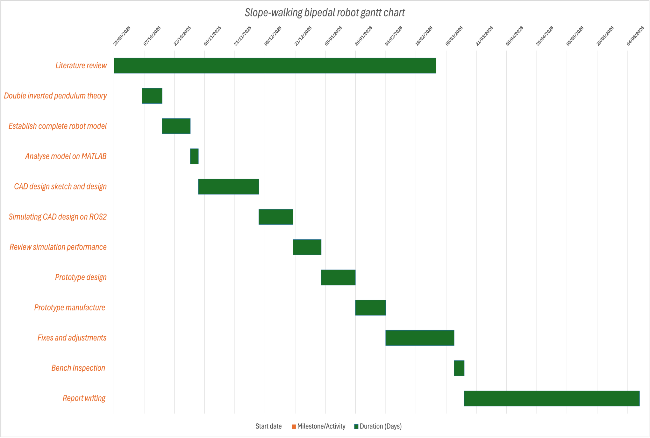
GANT chart new (25/11/25)
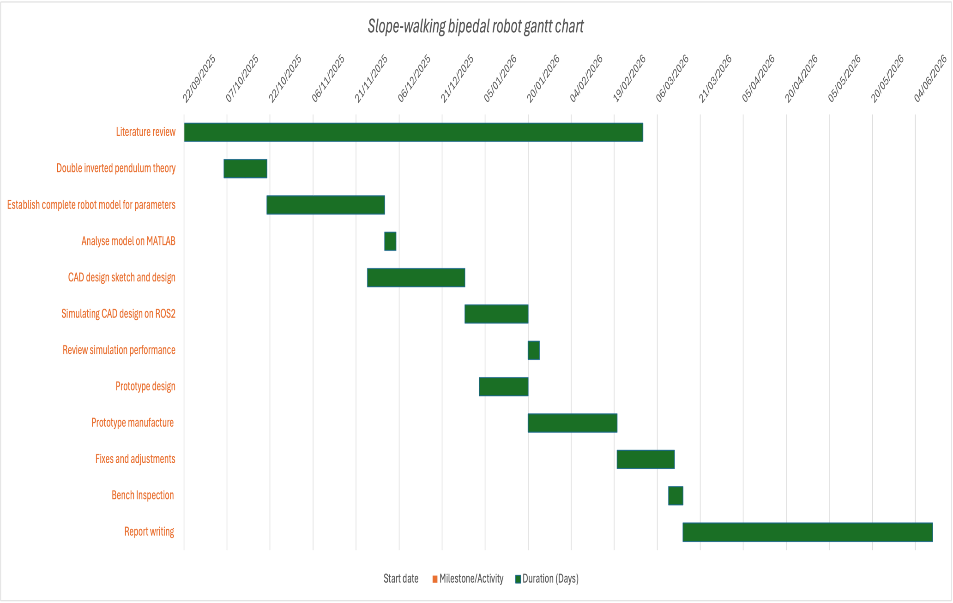

Appendix 2. The risk assessment form.

Appendix 3. FYP ethics self-assessment.

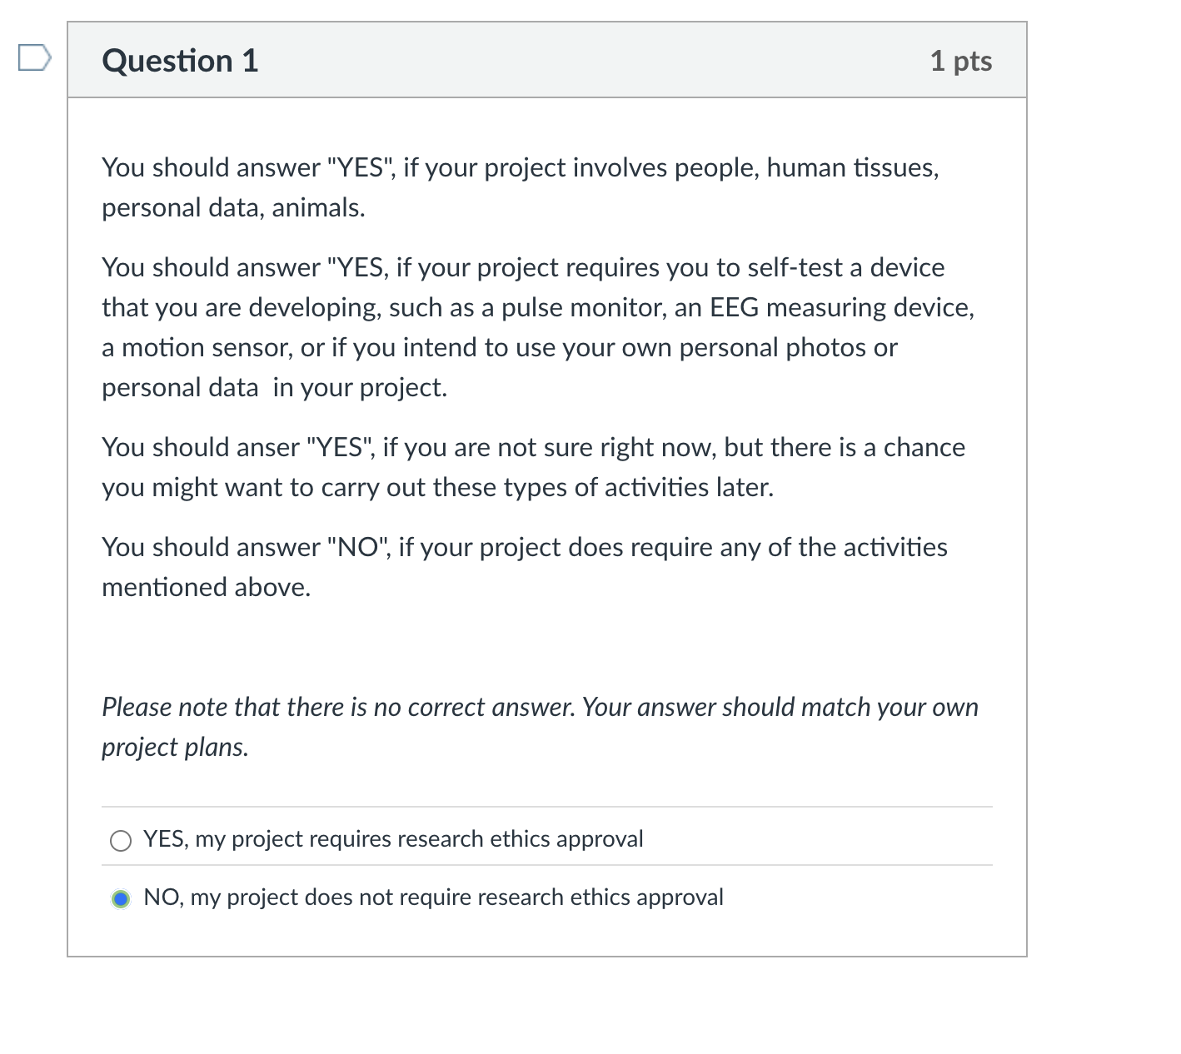

References
[1] T. McGeer, “Passive dynamic walking,” The International Journal of Robotics Research, vol. 9, no. 2, pp. 62–82, Apr. 1990.

[2] M. Garcia, A. Chatterjee, A. Ruina, and M. Coleman, “The simplest walking model: Stability, complexity, and scaling,” Journal of Biomechanical Engineering, vol. 120, no. 2, pp. 281–288, 1998.

[3] S. H. Collins, A. Ruina, R. Tedrake, and M. Wisse, “Efficient bipedal robots based on passive-dynamic walkers,” Science, vol. 307, no. 5712, pp. 1082–1085, 2005.

[4] Boston Dynamics, “Atlas: The world’s most dynamic humanoid robot,” Boston Dynamics, 2024. [Online]. Available: https://www.bostondynamics.com/products/atlas

